Model Research

Project title: AI Response Quality Evaluator Agent
The project aims to evaluate AI-generated responses automatically using LLM-as-a-Judge techniques, evidence retrieval, and multiple specialized evaluation agents. The system assesses relevance, factual accuracy, hallucination risk, and completeness, then combines the results into an explainable quality verdict.

Research area
A. LLM-as-a-Judge - A large language model evaluates another model's response using a predefined rubric. It can provide numerical scores, explanations, and identified errors.
Application: Power the relevance, accuracy, completeness, and verdict agents.
Limitation: The judge can also make mistakes or show bias, so its results must be tested against human-labelled examples.

B. Hallucination detection - The system breaks an answer into factual claims and checks whether each claim is supported by reference evidence.
Application: Flag unsupported claims, contradicted statements, and claims that cannot be verified.
Limitation: Missing evidence does not automatically prove a statement is false.

C. Retrieval-Augmented Generation (RAG) - RAG retrieves relevant passages from reference documents and supplies them as context to the evaluator.
Application: Ground accuracy and hallucination assessments in available evidence.
Limitation: Poor document quality or retrieval can lead to incorrect evaluations.

D. Evaluation metrics - The system measures response relevance, accuracy, completeness, factual grounding, and final verdict quality.
Application: Produce individual scores, explainable verdicts, and batch-level analytics.

Existing evaluation frameworks
Framework | Main purpose | How it helps to our project
RAGAS | Evaluates RAG and LLM applications using metrics | Guides faithfulness, response relevance, and factual correctness metrics.
TruLens | Evaluates LLM applications using feedback and metrics | Guides relevance and groundedness evaluation.
LLM-as-a-Judge | Uses an LLM to score another model's output | Provides the basis for your five judge agents.

Model selection
We need three types of models or components:
Component | Recommended choice | Reason
Judge model | Gemini API or another accessible instruction-following LLM | Generates structured scores and explanations
Embedding model | sentence-transformers/all-MiniLM-L6-v2 | Converts text into numerical vectors for semantic retrieval
Vector index | FAISS | Searches for relevant document chunks efficiently

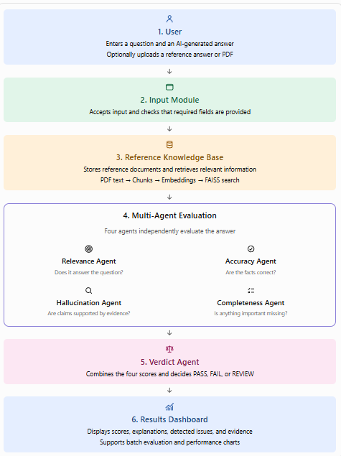
System Architecture

What are the technologies doing?
- Streamlit: Creates the webpage where the user enters the question and answer.
- Python: Connects all the modules and agents.
- LLM API: Powers the judge agents that evaluate the response.
- Sentence Transformers: Converts reference text into numerical vectors called embeddings.
- FAISS: Finds reference passages that are semantically similar to the query.
- Pandas and Plotly: Process batch results and display charts.

